Team Avengers

Section 2

**Final Project Report**

San José State University

Charles W. Davidson College of Engineering

CMPE 172 Enterprise Software Platforms

Professor : Andrew Bond

**Aye Swe, Zhonglin Liang**

December 4, 2018

**TABLE OF CONTENTS**

**Background and Objectives------------------------------------------------------------------------------- 2**

**Document Purpose------------------------------------------------------------------------------------------ 2**

**1.0 Functional Requirements----------------------------------------------------------------------------- 3**

**2.0 Technology and resource uses----------------------------------------------------------------------- 3**

**3.0 Use Cases ------------------------------------------------------------------------------------------------ 4**

**4.0 System Architecture and Stages of development process-------------------------------------- 5**

**5.0 Project Budget ----------------------------------------------------------------------------------------- 6**

**6.0 Project Accomplishments --------------------------------------------------------------------------- 6**

**7.0 Risk and Difficulty ------------------------------------------------------------------------------------ 7**

**8.0 Infrastructure Design---------------------------------------------------------------------------------- 7**

**9.0 Application Screenshots------------------------------------------------------------------------------- 8**

**Background and Objectives**

This report consists of the details of the project that the team has worked on this semester. The project is comprised of an enterprise human resource application which functions as one single point access with single sign on ranging from the CEO of the company, to human resource management associates, to employees. All users are able to access the system through their security level of the data access from anywhere, any device, and any environment as long as there is an internet connection. The application fosters the practice of continuous deployment by updating the application and database with a monitor system. Therefore, software updates do not inhibit the functionality of the application. The updates are conducted in real time which allows users in the system to receive data that is constantly up to date. Additionally, the system employs an integration with Twitter for a case by case convenient sign on process.

**Document Purpose**

This document provides the information of the application development process, technology used, resources used, and budget on the resources that the team has spent on the project. The project schedule and challenges encountered by the team are also reported.

Target Audience

This document can be referenced by

* Shareholders
* Students who wants to develop similar projects
* Project Managers

Scope

The scope of the document is to explain the step by step development states of the Avenger Human Resource Management System. This document covers the information that is needed to be able to successfully develop the application. It also suggests resources to build the infrastructure involving networking protocols, security protocols, and application developments. It will also cover the third party multimedia integration in the application.

**1.0 Functional Requirements**

1. The user shall be able to log in to the system with SSO.
2. The user shall be able to execute authorized actions to the database
3. The user shall be able to view GitHub code with SSO.
4. The user shall be able to view Jenkins logs with SSO.
5. The user shall be able to log out of the current SSO session.

**2.0 Technology and resource uses**

The following tools were employed for the development of the application:

1. Jenkins as deployment and integration tool
2. Apache Tomcat as web server
3. CentOS as web application server operating system
4. Java as chosen application language
5. J2EE as application Platform
6. JSP as server page technology to work with front-end HTML pages
7. MySQL database as back-end data storage
8. GitHub as version control and integration repository to work with Jenkin
9. Amazon AWS cloud and other necessary framework and technologies.

**3.0 Use Cases**

1. **Use Case Name**: Employee sign in

**Actors**:

* User-employee
* Active Directory Access Control

**Use Case Description**: User provides credentials and is granted access to the system if they are accurate. Otherwise, access is denied.

**Use Cases**

2. **Use Case Name**: System administrator sign in

**Actors**:

* User-system administrator
* Active Directory Access Control

**Use Case Description**: User provides credentials and is granted access to the system if they (credentials) are accurate. Otherwise, access is denied.

3. **Use Case Name**: Access GitHub repository

**Actors**:

* User-system administrator
* Application

**Use Case Description**: Previously authenticated system administrator selects the github symbol at the top of the desktop page and is granted access to the github repository.

**4.0 System Architecture and Stages of development process**

First of all, we discussed the technology that we know and new technologies that we needed to learn. The team then agreed to use Java server pages, HTML, and CSS, Java language as application tools to develop as a Maven project. Maven is developed on Eclipse Java EE IDE.

We used GitHub repository as our version control system for our application development.

As for the enterprise infrastructure, the team used the Amazon AWS cloud. A Virtual Private Cloud was created in AWS and five instances were created. VPC has two subnets; one as a public subnet and the other as a private subnet. The two subnets communicate through the NAT device. A bastion host instance was created to manage the window server instances and resources. A bastion host and NAT device are located on the Elastic IP address of the AWS. For an extra layer of security ACL was created between the NAT device and main router. While the application server and Jenkins server are located in the public subnet of the VPC. The database server and Active Directory server are hosted in the private subnet.

The application server hosts the ubuntu server and the Tomcat web server. The Jenkins server utilizes the Docker for the dependency complexity. Jenkins is configured to integrate to the AD to get authorization for single sign on, web server to build the application and GitHub repository for continuous building process.

Database server hosts the application data in MYSQL database and is configured to integrate with web application and web application server.

A window server is hosted by AD and another window server is created to host the bastion server to communicate with the private inbound and outbound traffics for the resources in the private subnet of the VPC.

**5.0 Project Budget**

The team does not have any budget plan to supply the required resources since we planned to use Amazon AWS free tier instances. However, during the development process, the project needed an Elastic IP address for our AD server, and multiple instances were needed to pay for the resources for Amazon. For this reason according to our budget, the team had to undeployed our infrastructure in Amazon AWS as soon as the project was presented in the class and after recording the screen shots of the proof of our infrastructure.

**6.0 Project accomplishments**

Our project can develop Enterprise level infrastructure web application. We have learned new technology during the development process as they are required for use in our application. For instance, we didn’t have much experience in Amazon AWS cloud infrastructure, configuration of servers for network connections, and decision making on network security protocols for servers. We also learned how AD is the control as central controller for the authorization and single sign on system.

**7.0 Risk and Difficulty**

During the development process, we encountered the problem with integration of AD and MySQL community database server. Microsoft AD needed to have autho_pam.so plug in module in the database server. Unfortunately, the plug is only available in Enterprise edition.

**8.0 Infrastructure Design**

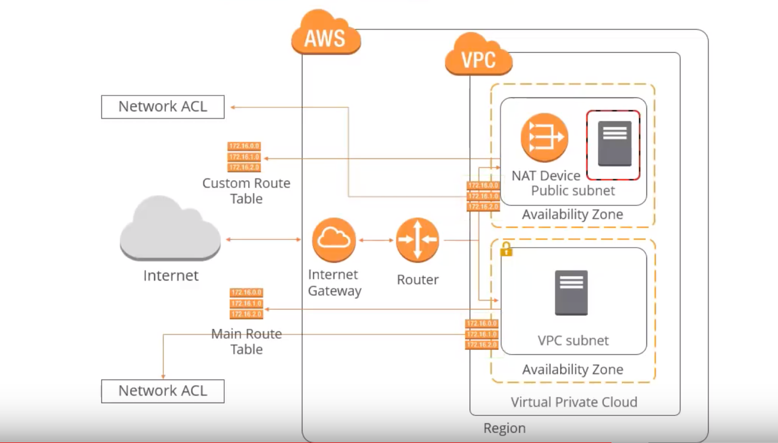

Figure 1: Infrastructure hosting project resources in AWS VPC with multi-level security.

**9.0 Application Screenshots**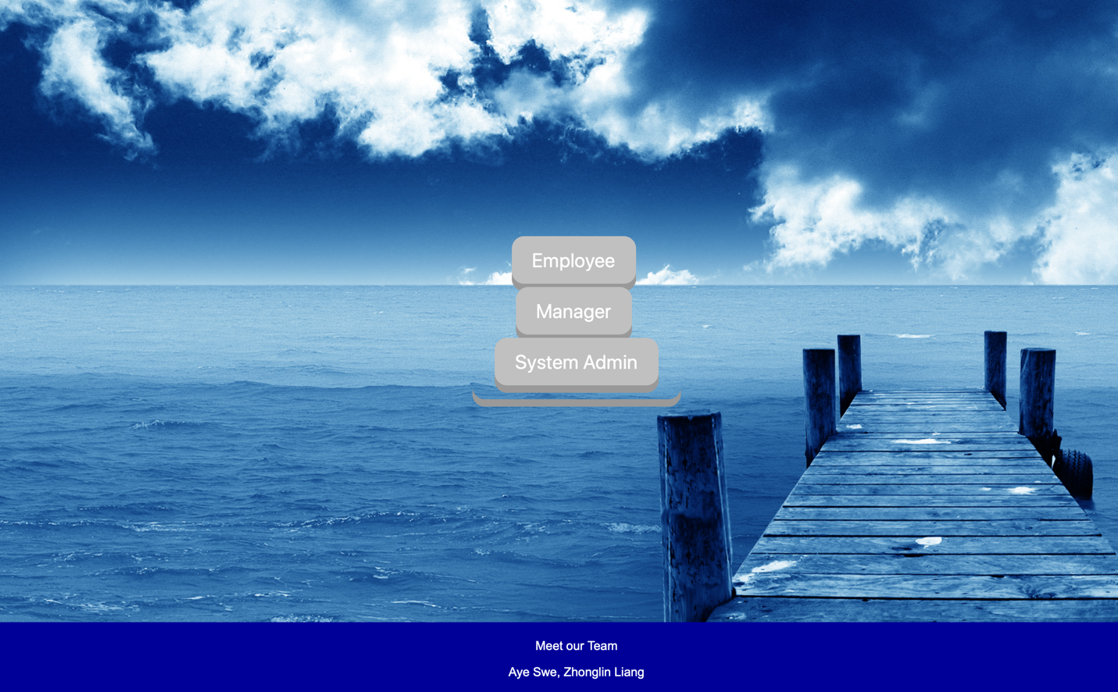

Figure 2: Application home page with Employee, Manager and System Admin login

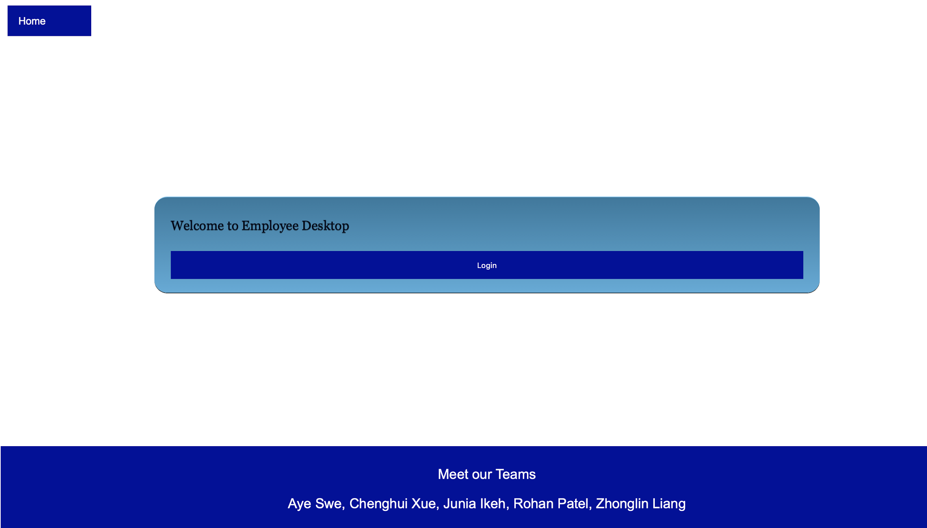

Figure 3: Employee Desktop login, authenticated by the Active Directory access control

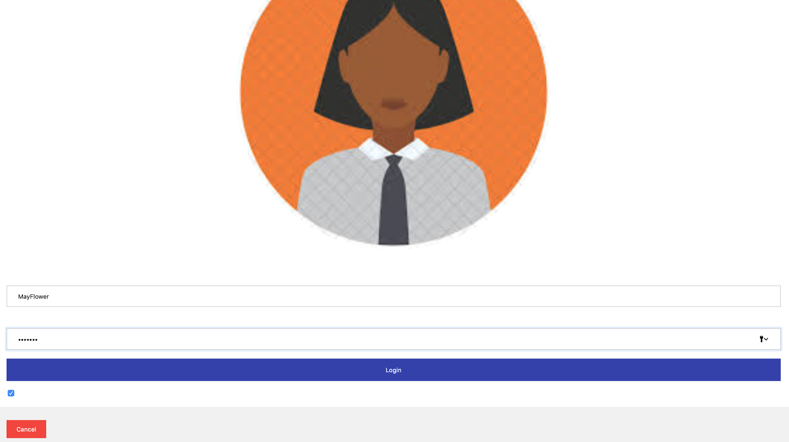

Figure 4: Employee login form which authenticates with AD

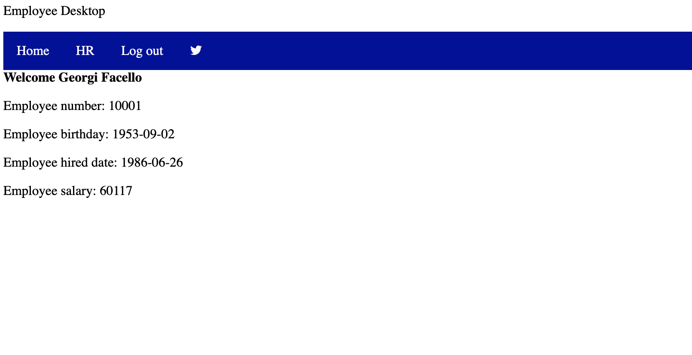

Figure 5: Employee Desktop after successful login with employee information from database server and twitter social media feature

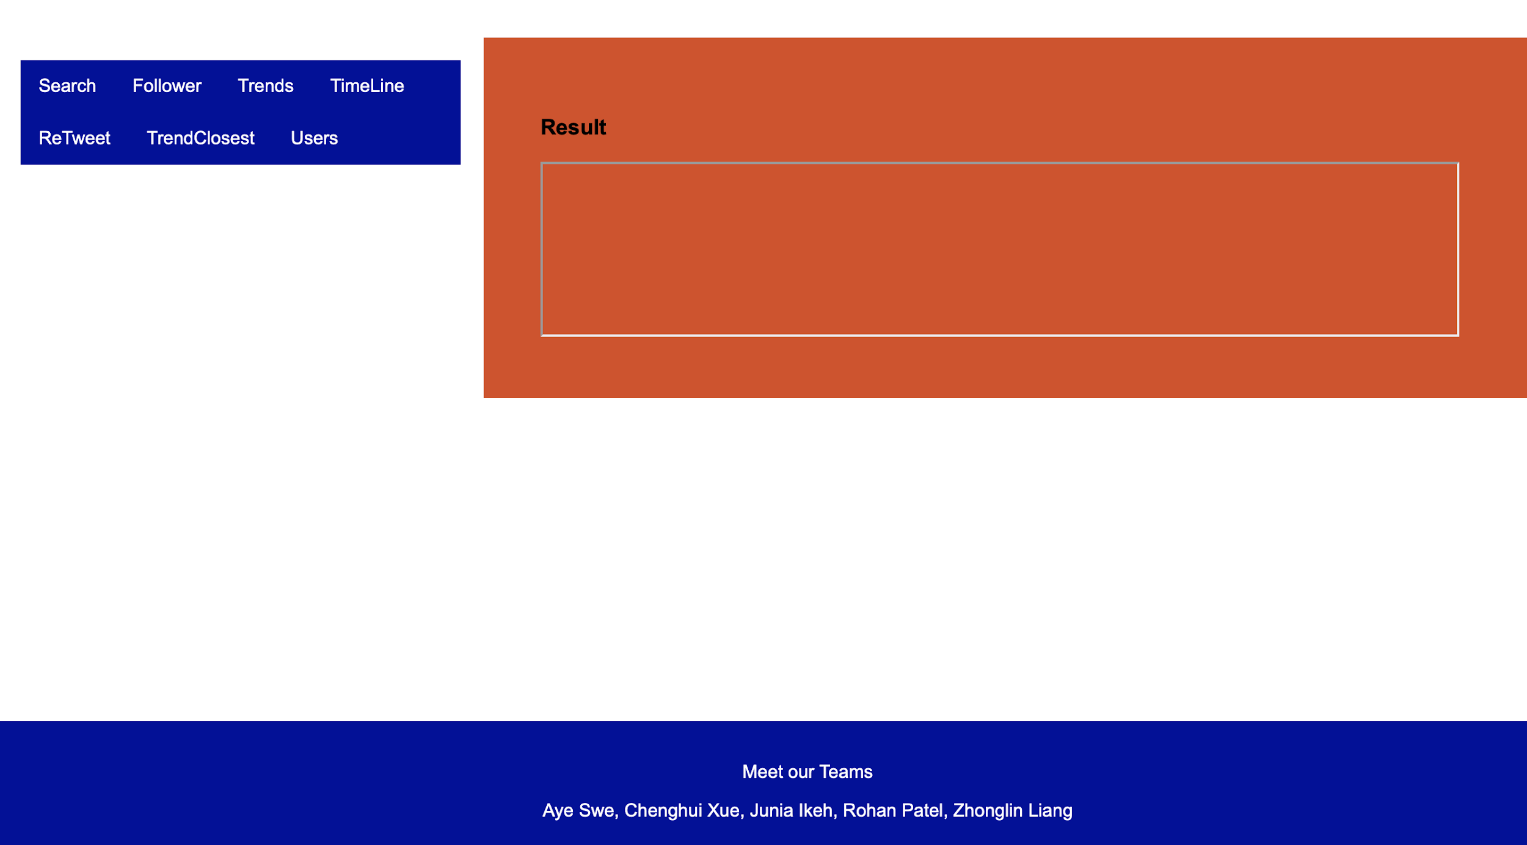

Figure 6: Twitter application integrated to the application

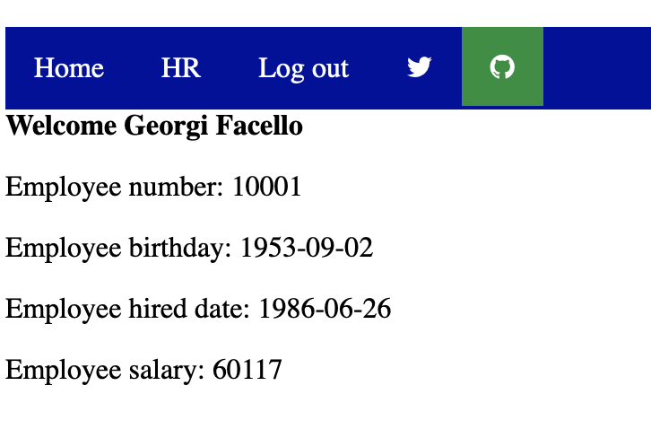

Figure 7: System Administrator Desktop with GitHub repository access through application

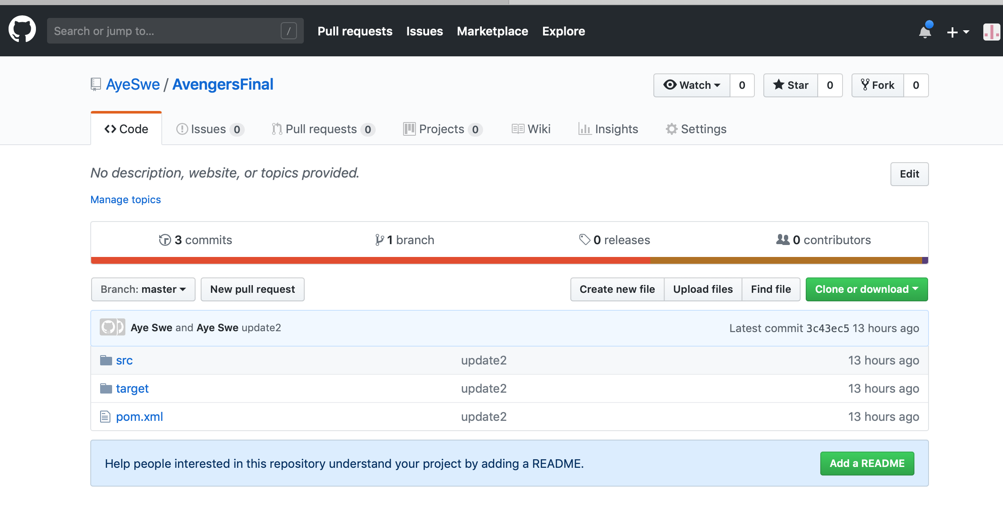

Figure 8: Github repo through System Admin Desktop.

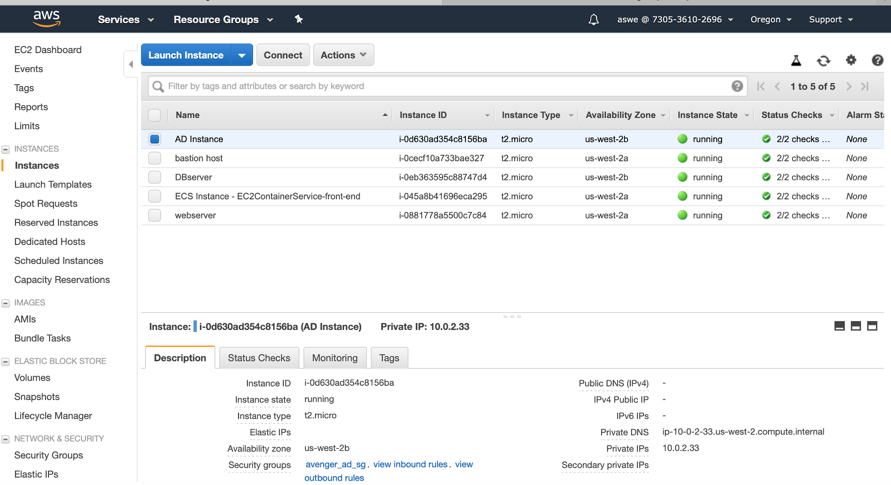

Figure 9: Active Directory Domain in Aws VPN with private subnet IP address which can be accessible through bastion host.

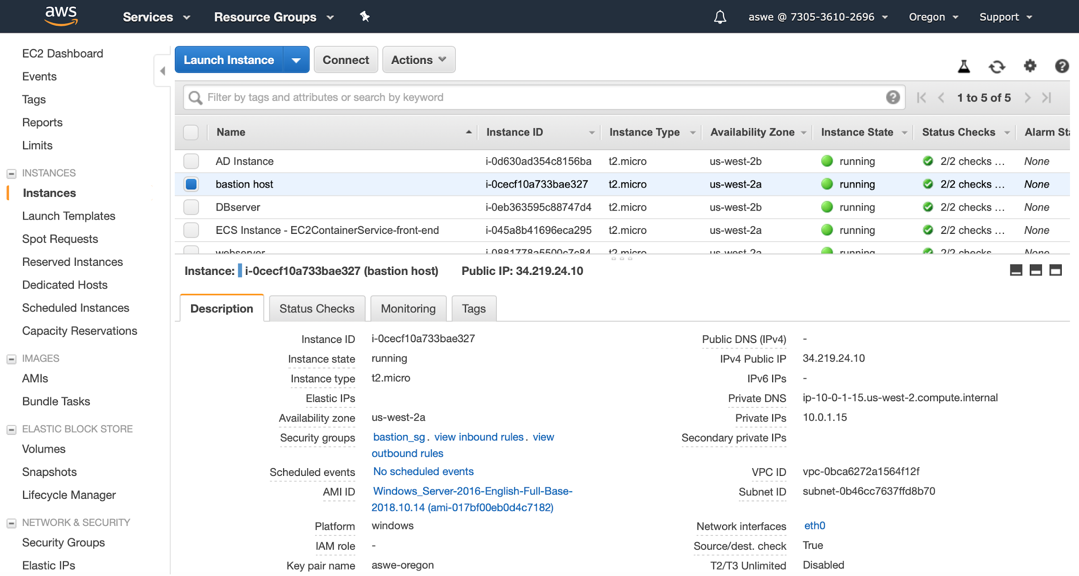

Figure 10: Bastion host window server utilized to manage AD server and DB server, located in the VPN’s private subnet

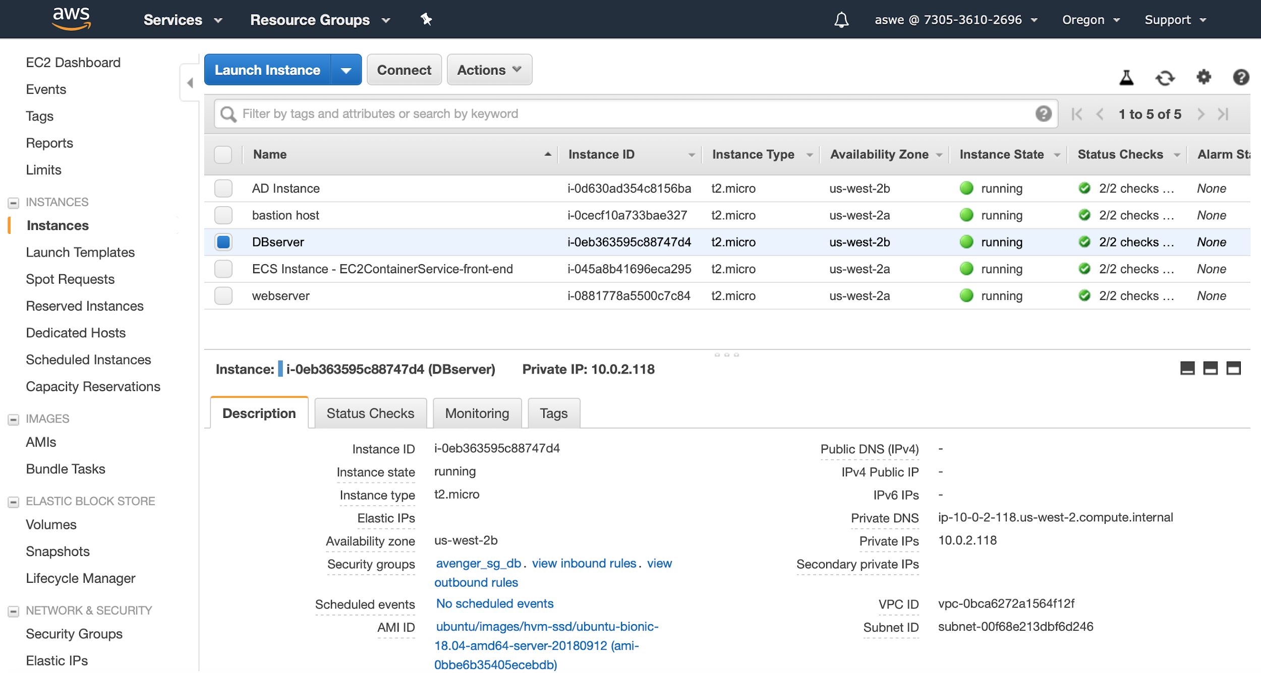

Figure 11: Application Database server located in VPN’s private subnet and accessible through bastion host to manage

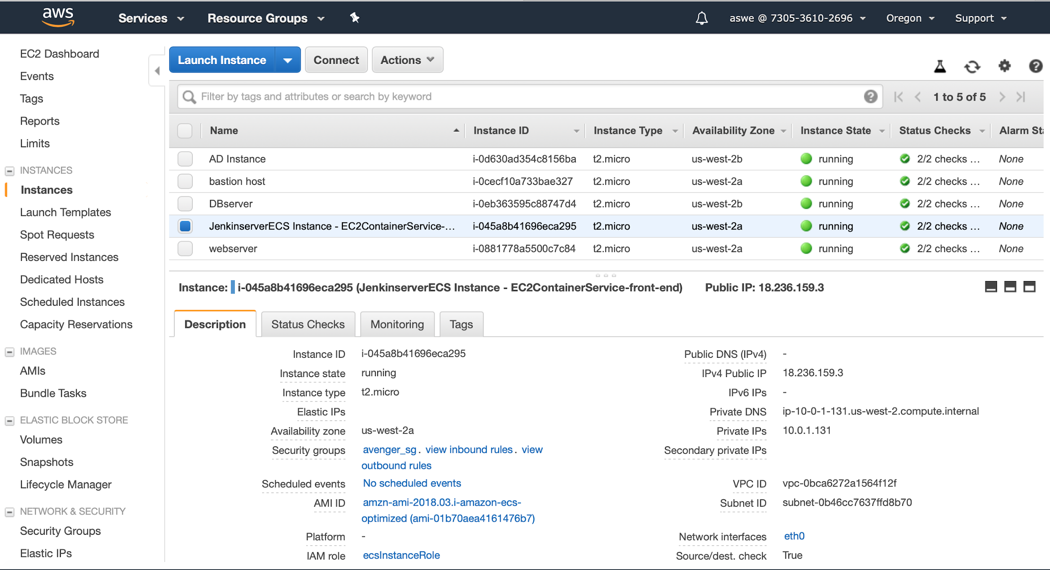

Figure 12: Jenkins server, located in public IP which can be logged in with Active Directory Domain by applying SSO functionality

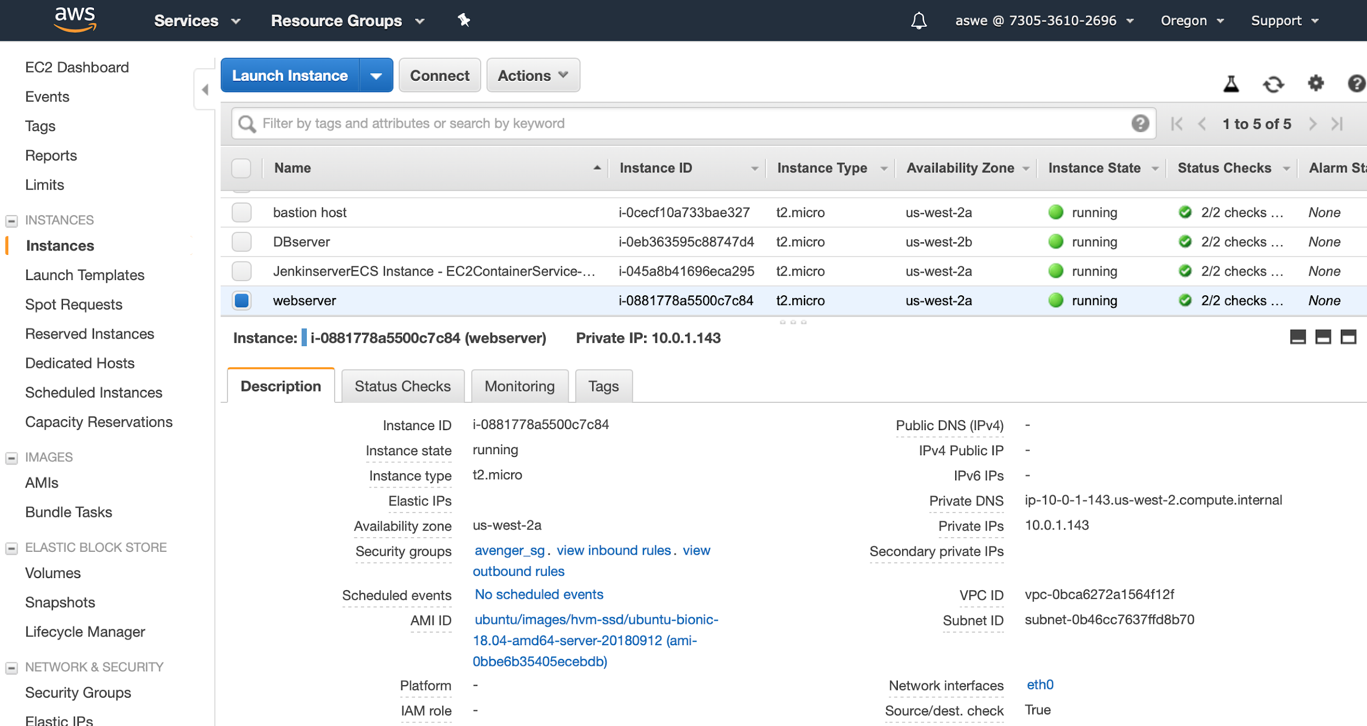

Figure 13: Tomcat server hosting web application server, built by Jenkins.

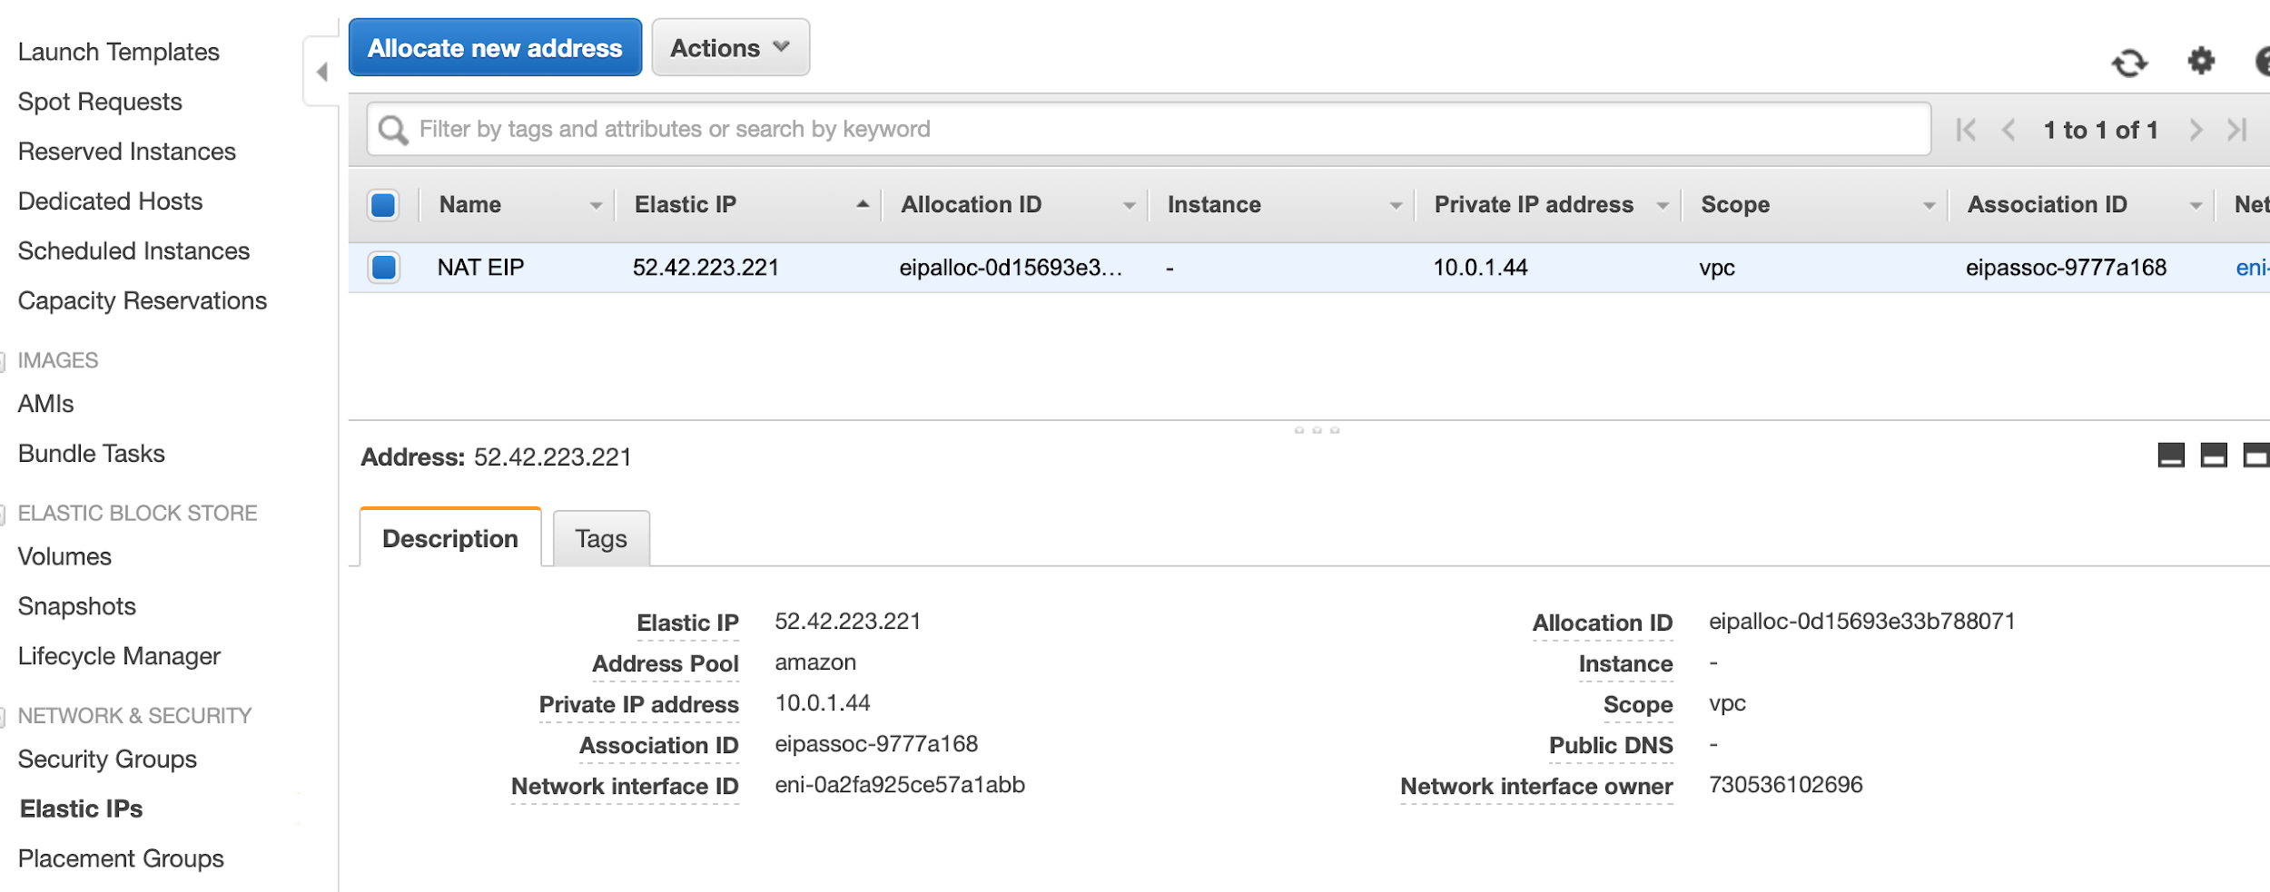

Figure 14: NAT device with elastic IP for controlling

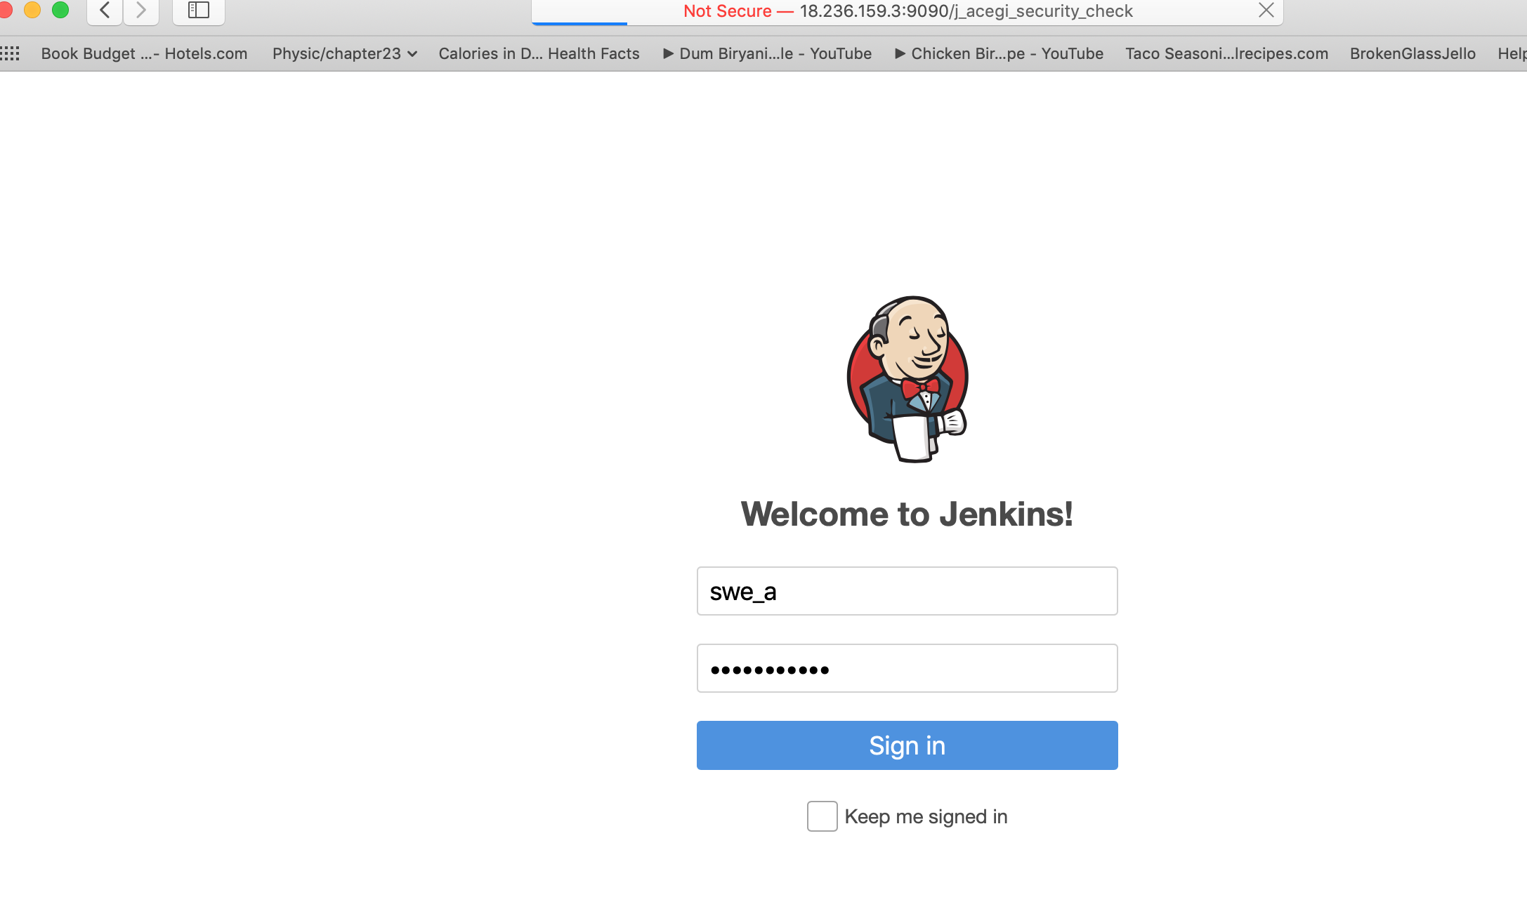

Figure 15: Jenkins server hosting Docker with Jenkins enabled to use SSO functionality with user group in Active directory domain

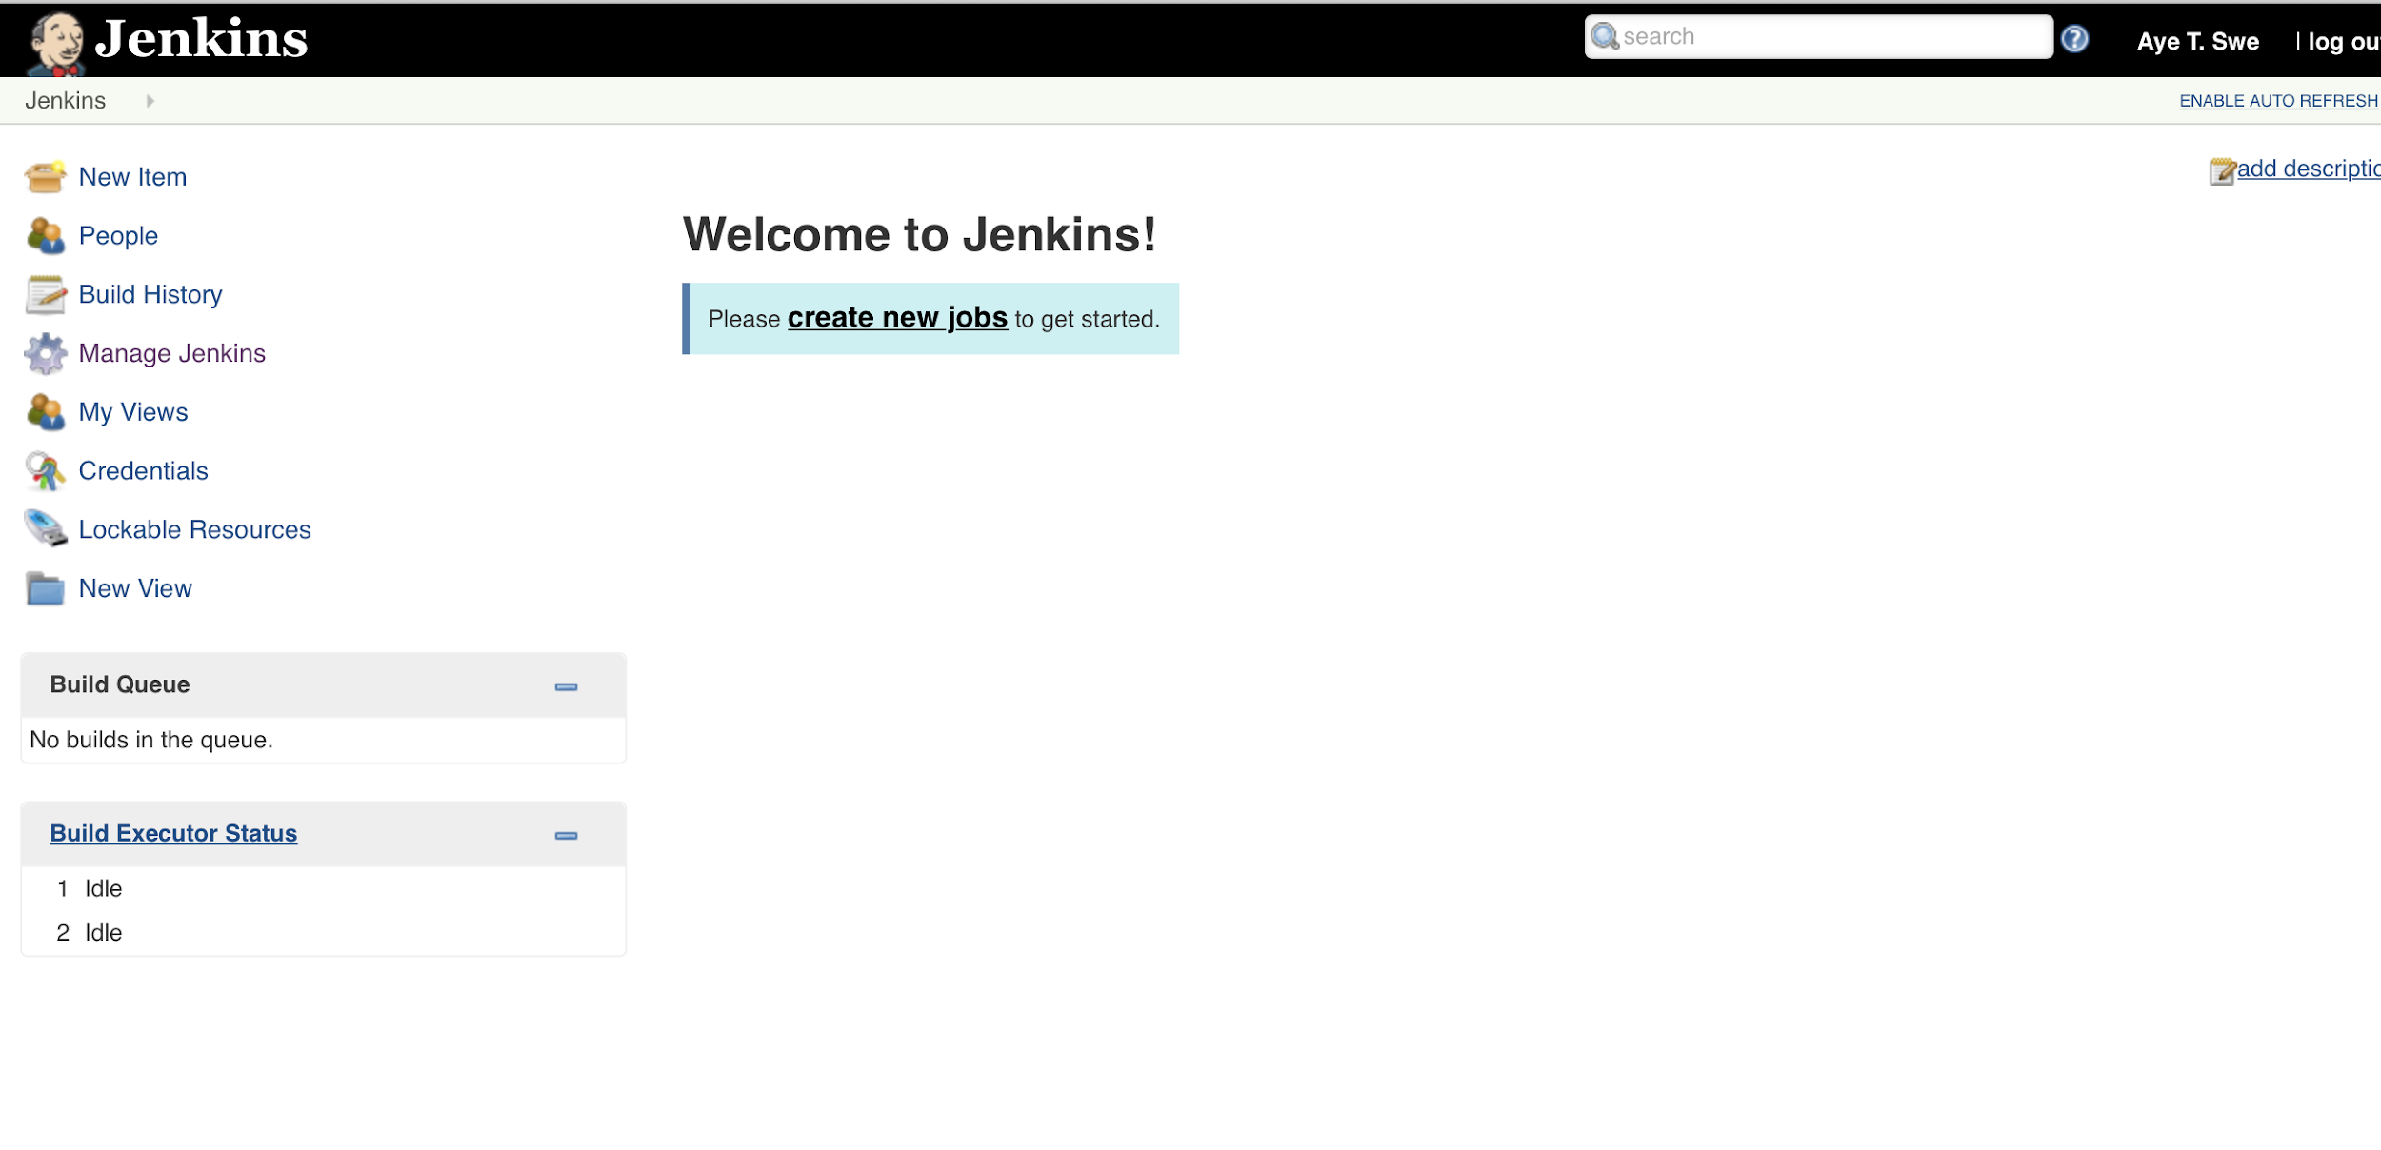

Figure 15: Jenkins successfully logged in with Active Directory user group

Figure 16: Database server enabling with AD domain user group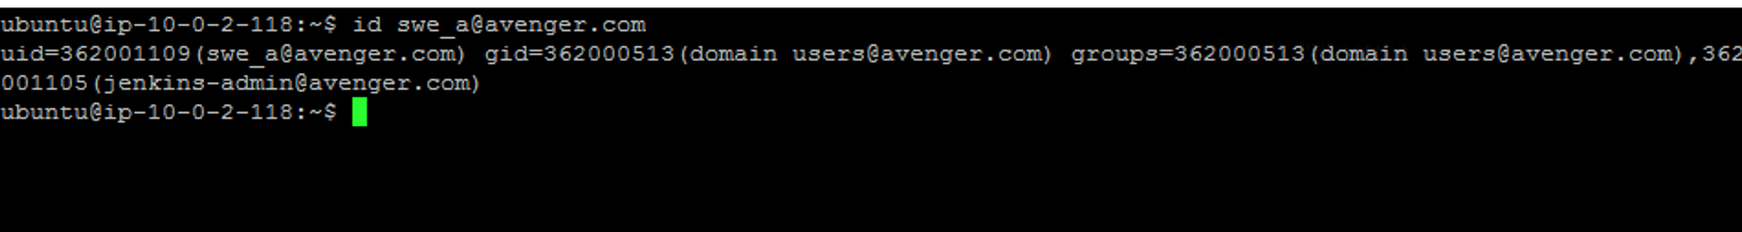

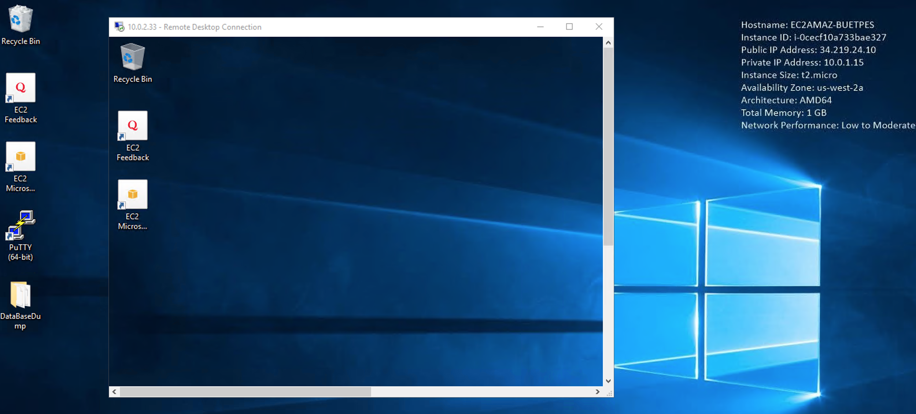

Figure 17: Bastion host server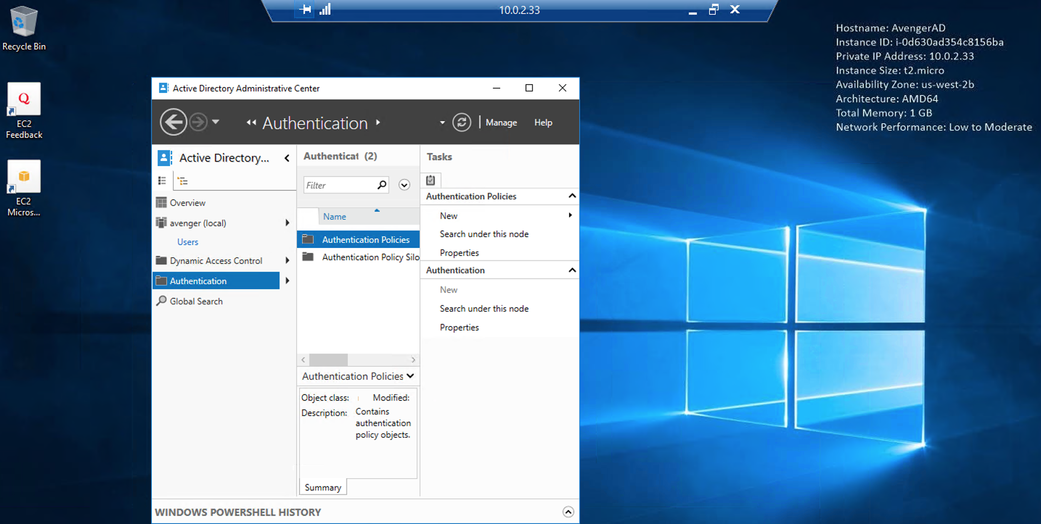

Figure 18: Active Directory Domain hosting window server

Figure 19: A user group account in Active Directory Domain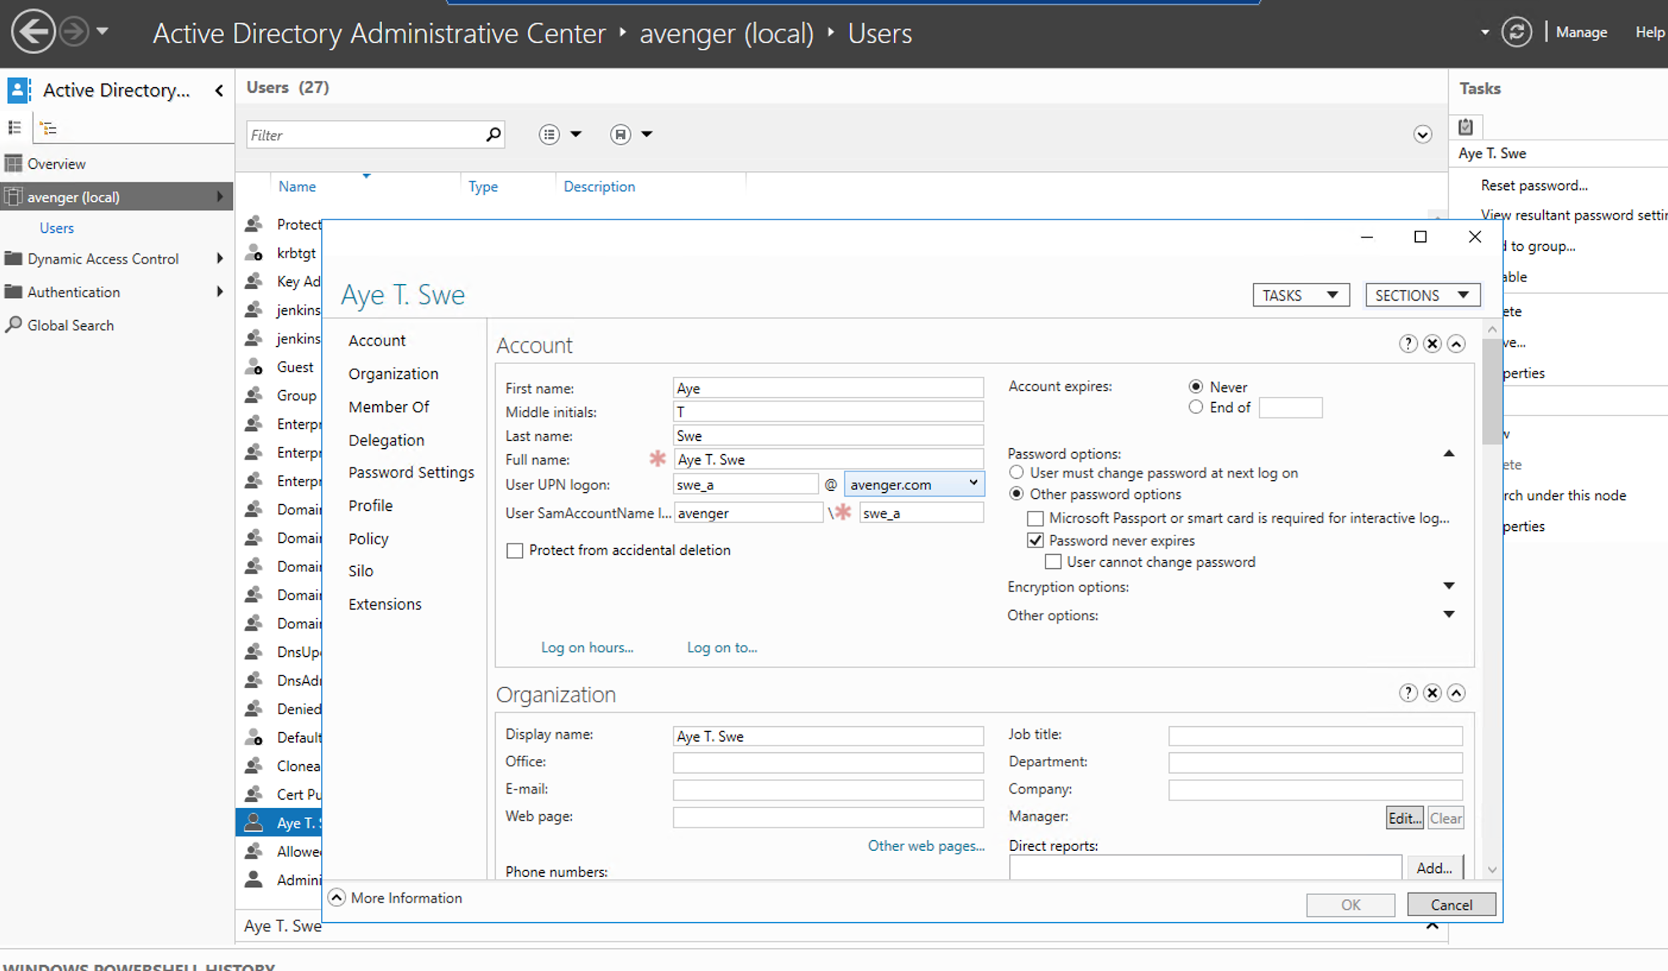

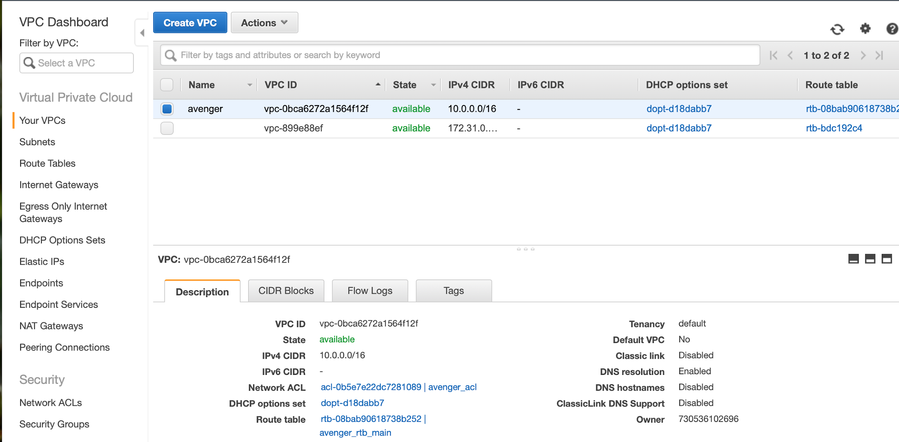

Figure 20: Layer of security as ACL in VPC

Figure 21: Project’s private subnet and public subnet in VPN.e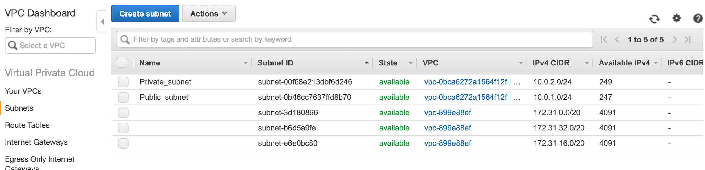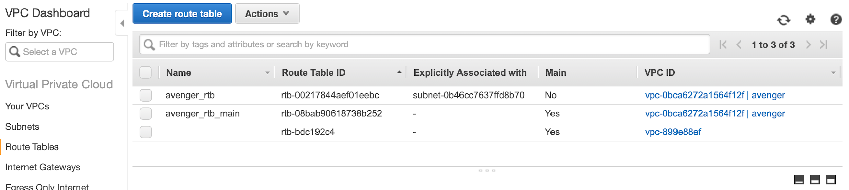

Figure 22: Project’s route table to VPN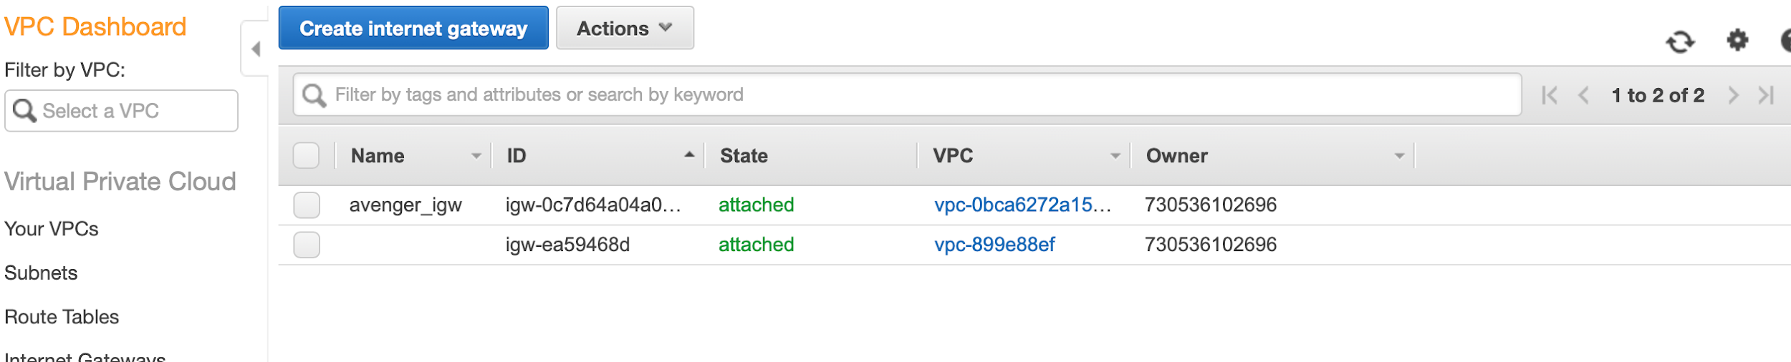

Figure 23: Internet gateway of the whole infrastructure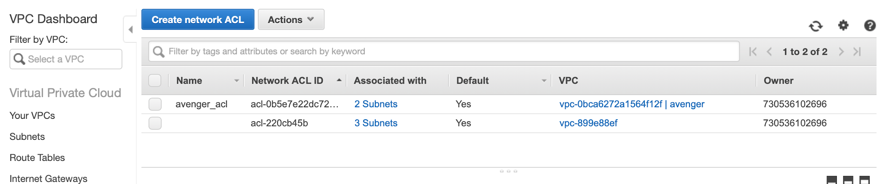

Figure: Extra security network layer as ACL, channels traffic from AD and application web server to database server in private subnet.

References

Adding an Amazon RDS DB Instance to Your Java Application Environment. Retrieved from

<https://docs.aws.amazon.com/elasticbeanstalk/latest/dg/java-rds.html>

Best Practices for Managing AWS Access Keys. Retrieved from <https://docs.aws.amazon.com/general/latest/gr/aws-access-keys-best-practices.html>

How to setup Active Directory Authentication in MySQL running on Linux. Retrieved from

<https://runops.wordpress.com/2015/03/19/how-to-setup-active-directory-authentication-in-mysql-running-on-linux/>

MariaDB with Active Directory Authentication VIA PAM Module. Retrieved from

<https://techblog.jeppson.org/2017/12/mariadb-active-directory-authentication-via-pam-module/>

https://www.w3schools.com